**N.SARDHIK**

**192211523**

**Experiment-3**

Create a simple cloud software application for Property Buying & Rental process (In Chennai city) using any Cloud Service Provider to demonstrate SaaS

**IMPLEMENTATION:**

**Step-1:**

Go to zoho.com.

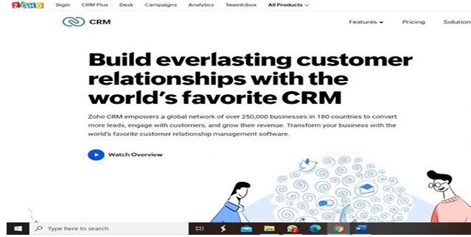

**Step-2:**

Log into the zoho.com

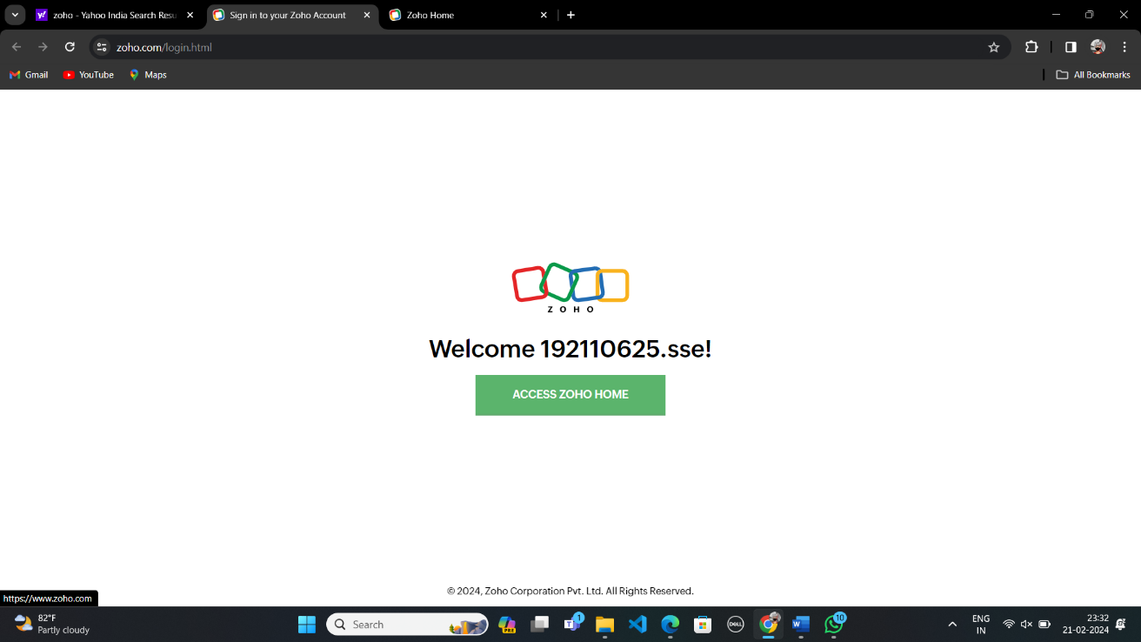

**Step-3:**

Select one application step.

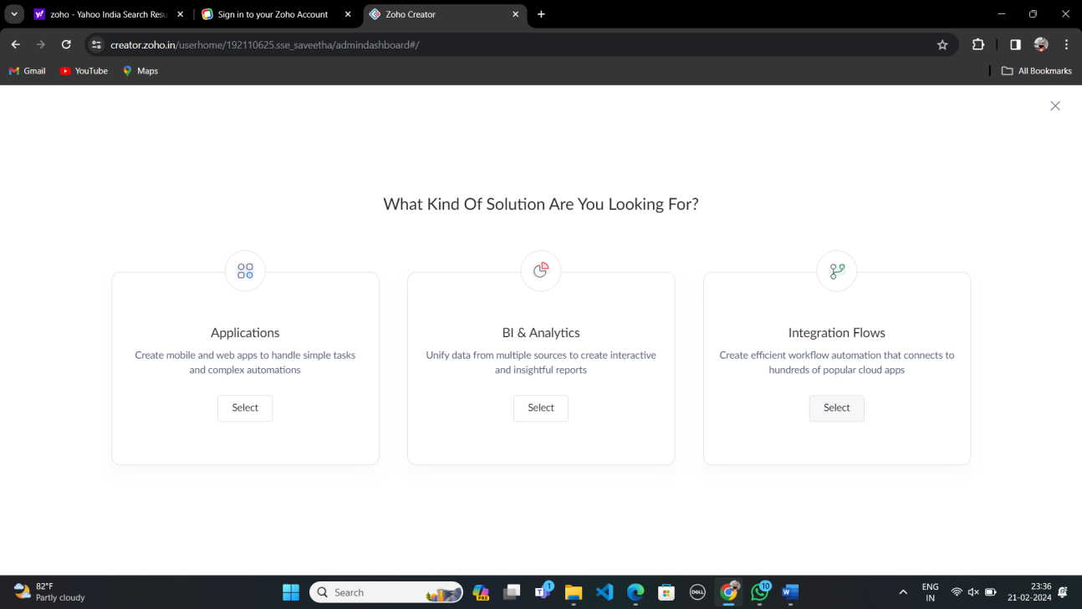

**Step-4:**

Enter application name as flight reservation system.

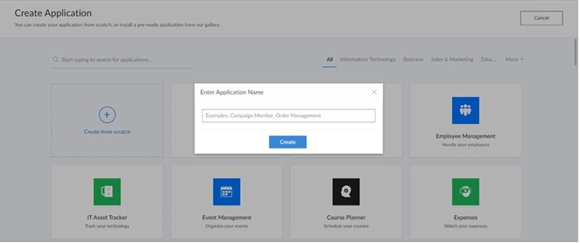

**Step-5:**

Created new application flight reservation system.

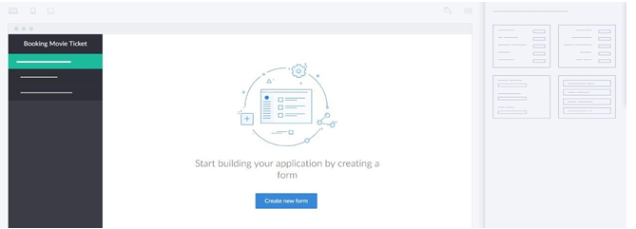

**Step-6:**

Create a new form and name it as Contact us.

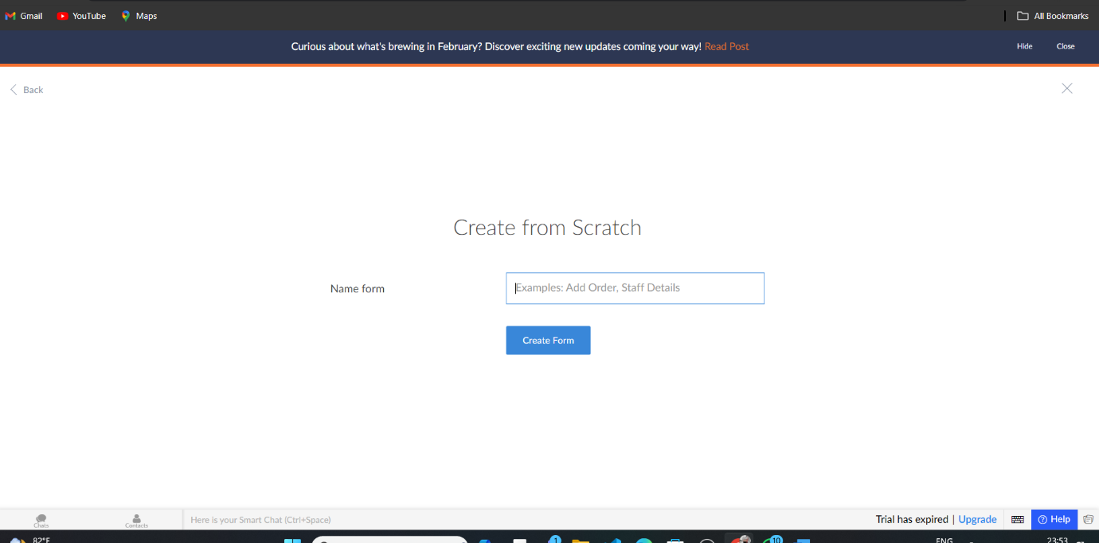

**Step-7:**Create Contact us.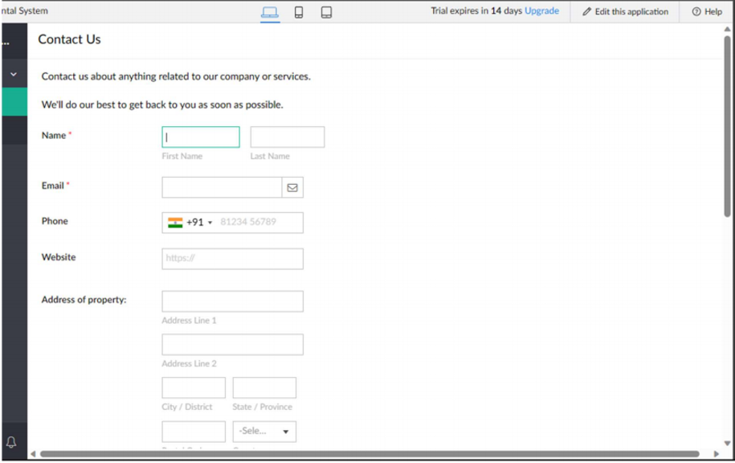

**Step-8:**

Create a new form and name it as Buying and Rental Details.



**Step-9:**

Create Buying and Rental Details.

